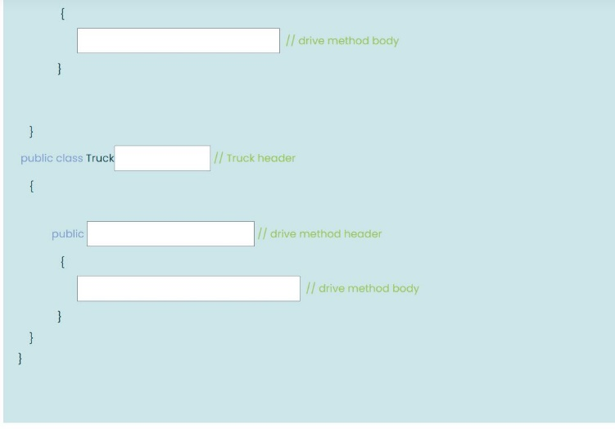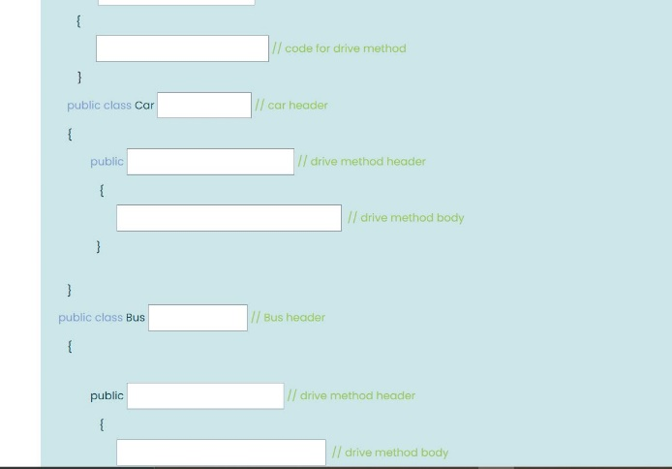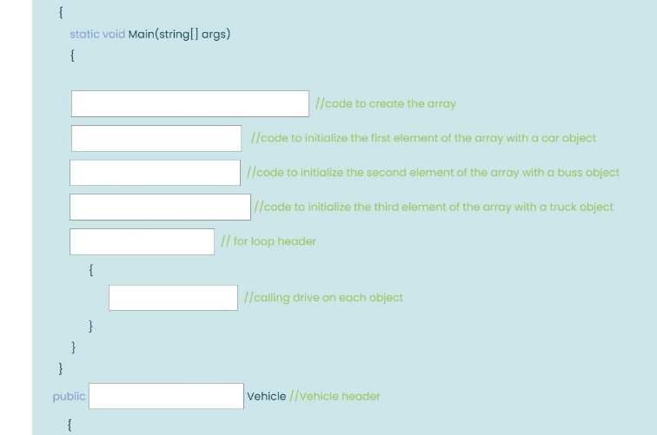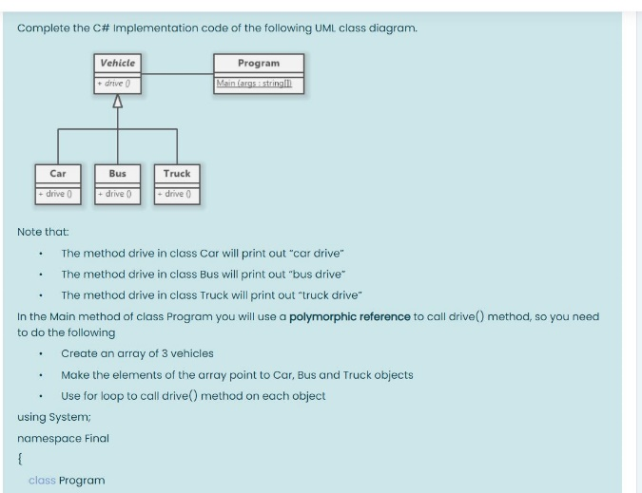

using System;

namespace Final

{

class Program

{

static void Main(string[] args)

{

Vehicle[] array = new Vehicle[3]; //code to create the array

array[0] = new Car(); //code to initialize the first element of the array with a car object

array[1] = new Bus(); //code to initialize the second element of the array with a bus object

array[2] = new Truck(); //code to initialize the third element of the array with a truck object

for (int i = 0; i < array.Length; i++) // for loop header

{

array[i].drive(); //calling drive on each object

}

}

}

public interface Vehicle //Vehicle header

{

void drive(); // code for drive method

}

public class Car : Vehicle // Car Header

{

public void drive() // drive method header

{

Console.WriteLine("car drive"); // drive method body

}

}

public class Bus : Vehicle // Bus header

{

public void drive() // drive method header

{

Console.WriteLine("bus drive"); // drive method body

}

}

public class Truck : Vehicle // Truck header

{

public void drive() // drive method header

{

Console.WriteLine("truck drive"); // drive method body

}

}

}

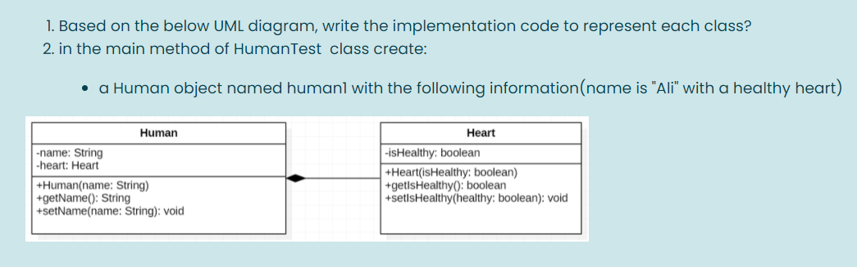

using System;

public class Heart

{

//creating variable

private bool isHealthy;

//constructor

public Heart(bool isHealthy)

{

//setting value

this.isHealthy = isHealthy;

}

//getter and setter method

public bool getItsHealthy()

{

return isHealthy;

}

public void setItsHealthy(bool isHealthy)

{

this.isHealthy = isHealthy;

}

}

public class Human

{

//creating variable

private string name;

private Heart heart;

//constructor

public Human(string name, Heart heart)

{

//setting value

this.name = name;

this.heart = heart;

}

//getter and setter method

public string getName()

{

return name;

}

public void setName(string name)

{

this.name = name;

}

}

class HumanTest

{

static void Main()

{

//create Heart and Human object

Heart heart = new Heart(true);

Human human1 = new Human("Ali", heart);

//print details

Console.WriteLine("Name : " + human1.getName());

Console.WriteLine("Is Healthy Heart? " + heart.getItsHealthy());

}

}

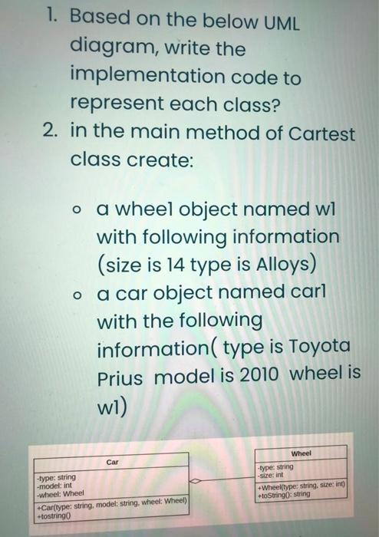

public class Car

{

private String type; //attributes

private int model;

private Wheel w;

Car(String t, int m, Wheel w1) //Constructor

{

type = t;

model = m;

w = w1;

}

public String toString() //toString method

{

return type + " " + model + " " + w.toString();

}

}

public class Wheel

{

private String type; //attributes

private int size;

Wheel(String t, int s) //Constructor

{

type = t;

size = s;

}

public String toString() //Tostring Method

{

return type + " " + size;

}

}

public class Cartest

{

public static void main(String[] args)

{

Wheel w1 = new Wheel("Alloys", 14); //object made

Car car1 = new Car("Toyota Prius", 2010, w1);

Console.WriteLine(car1);

}

}

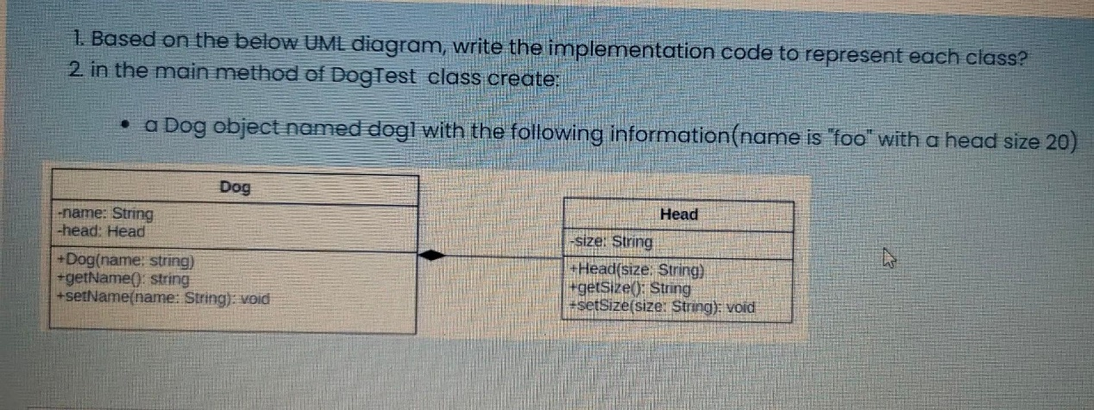

using System.IO;

using System.Xml.Linq;

public class Cartest

{

static void Main(string[] args)

{

Head head = new Head("20");

Dog dog1 = new Dog("foo ", head);

Console.WriteLine(dog1.toString());

}

}

public class Dog

{

string size;

Head head;

public Dog(string size, Head head)

{

this.size = size;

this.head = head;

}

public string getSerialNumber()

{

return size;

}

public void setSerialNumber(string Size)

{

Size = size;

}

public string toString()

{

return "name is " + size + "with a head size " + head ;

}

}

public class Head

{

string name;

public Head(string name)

{

this.name = name;

}

public string getHorsePower()

{

return name;

}

public void setHorsePower(string Name)

{

Name = name;

}

}

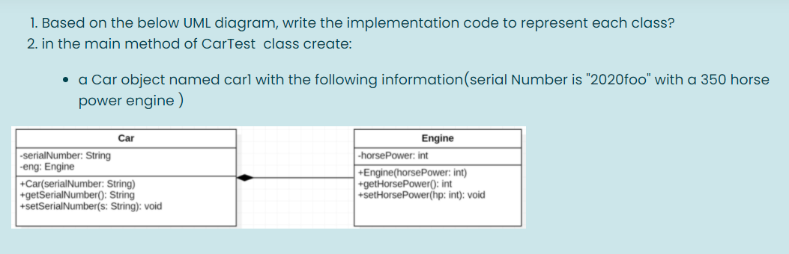

using System.IO;

public class Cartest

{

static void Main(string[] args)

{

Engine engine = new Engine(350);

Car car1 = new Car("2020foo ", engine);

Console.WriteLine(car1.toString());

}

}

public class Car

{

string serialNumber;

Engine eng;

public Car(string serialNumber, Engine eng)

{

this.serialNumber = serialNumber;

this.eng = eng;

}

public string getSerialNumber()

{

return serialNumber;

}

public void setSerialNumber(string s)

{

s = serialNumber;

}

public string toString()

{

return "serial Number is " + serialNumber + "with a " + eng + "horse power engine ";

}

}

public class Engine

{

int horsePower;

public Engine(int horsePower)

{

this.horsePower = horsePower;

}

public int getHorsePower()

{

return horsePower;

}

public void setHorsePower(int hp)

{

hp = horsePower;

}

}